GCP cloud run function

Click on CloudRun

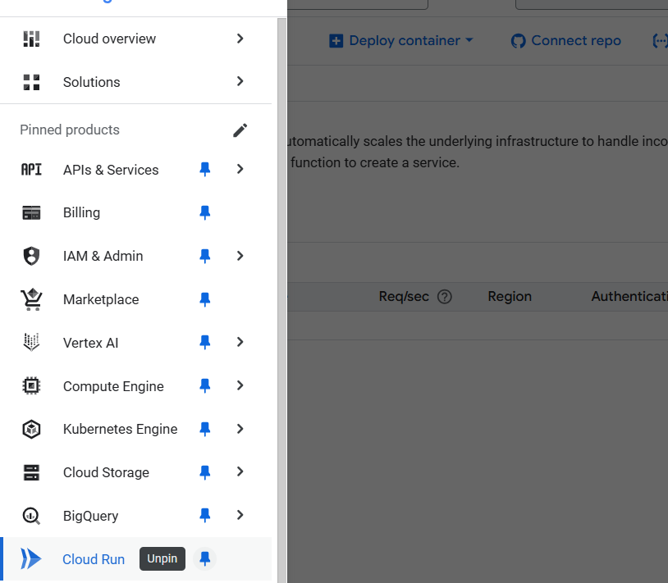

Click on write a function

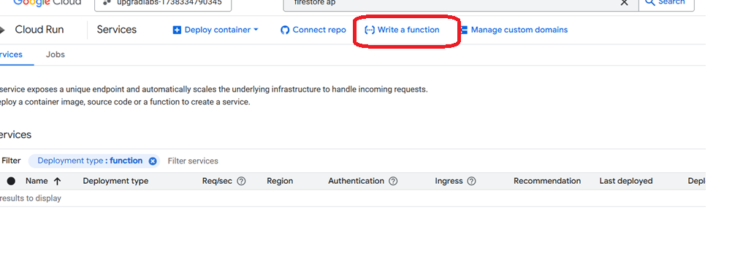

Select inline function

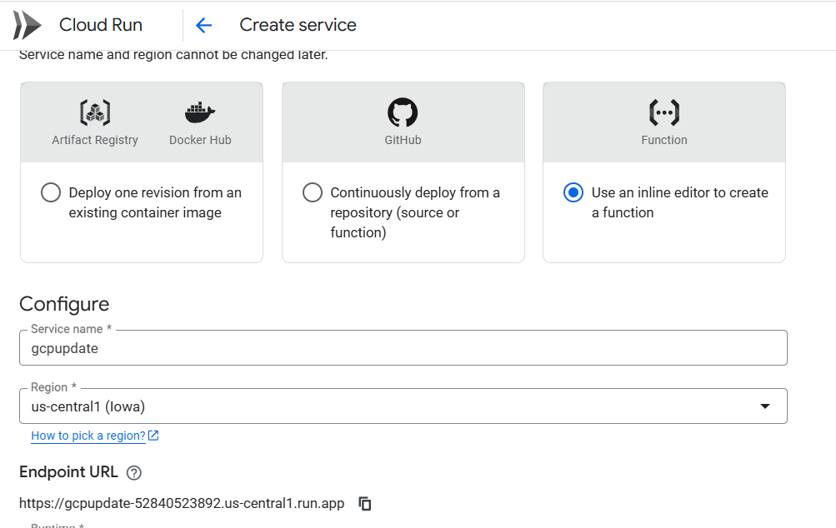

Click on Add trigger option and select cloud storage

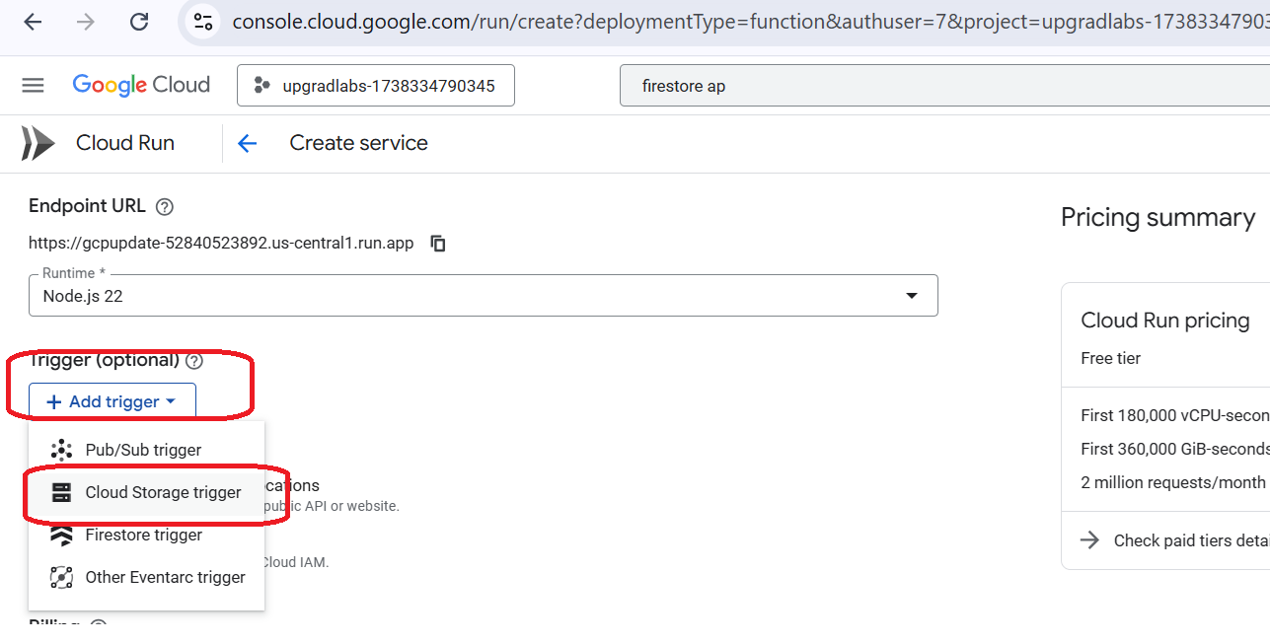

In-case its prompts enable the api

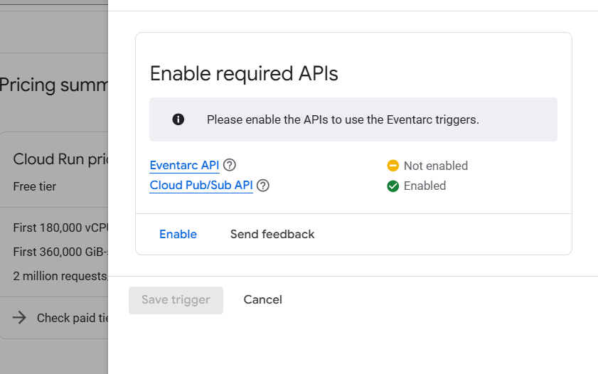

Provide trigger type🡪 Cloud storage and click on Enable All

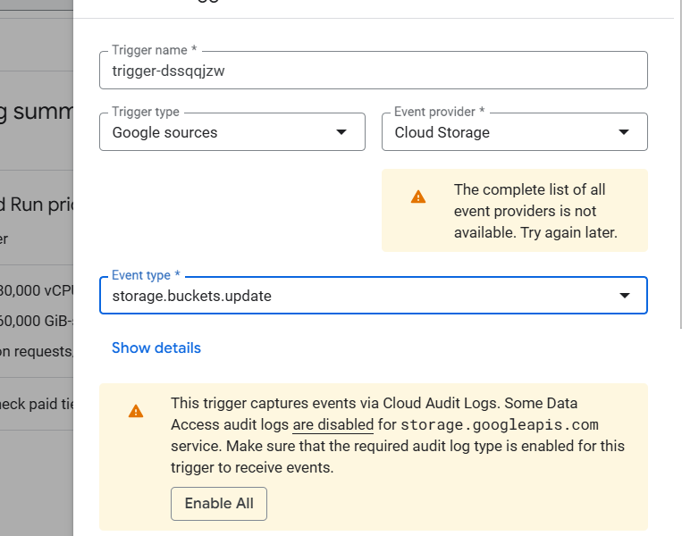

Select the event type

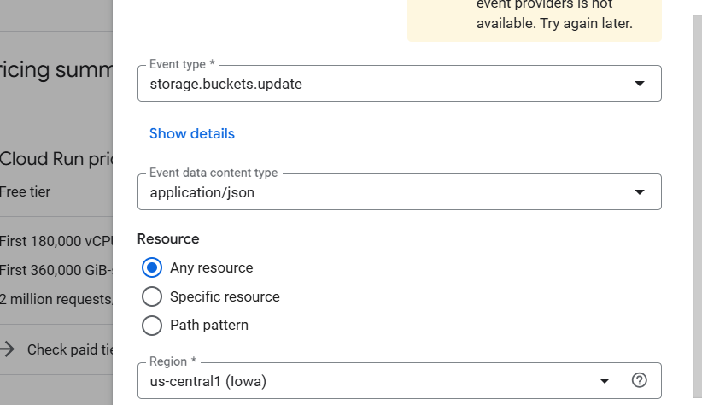

Save trigger

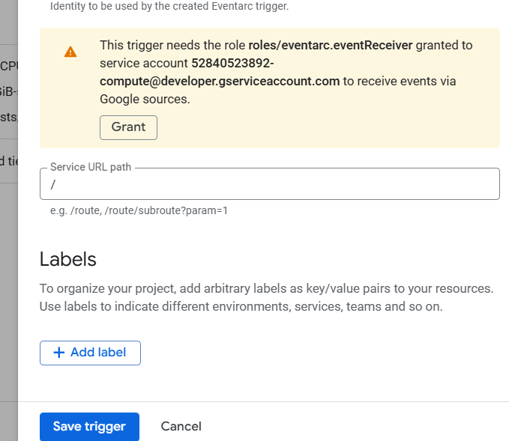

Authentication

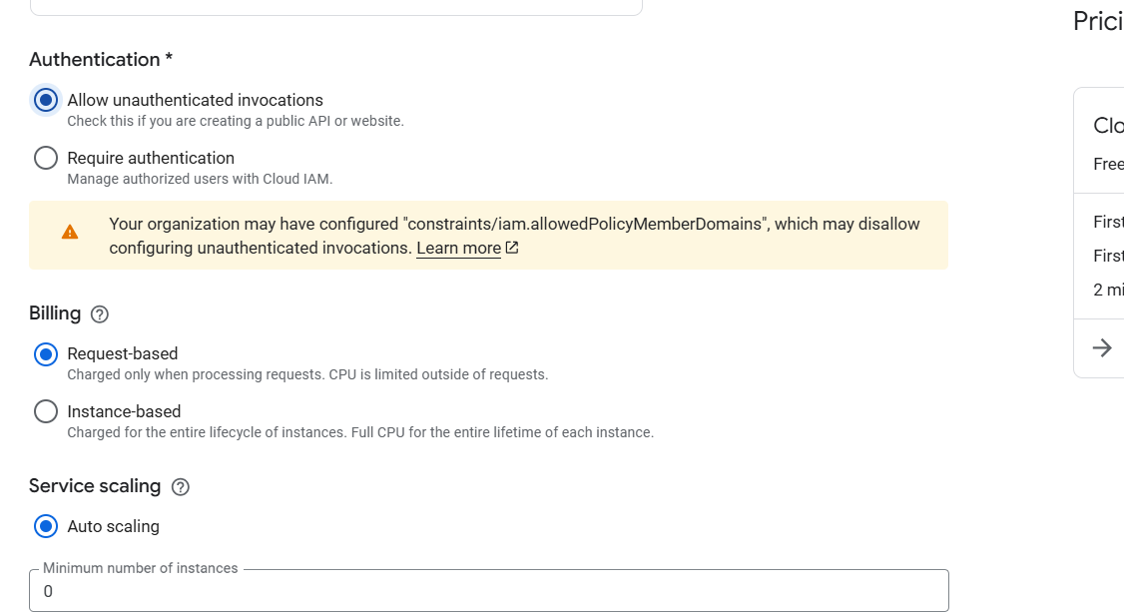

Click on Create

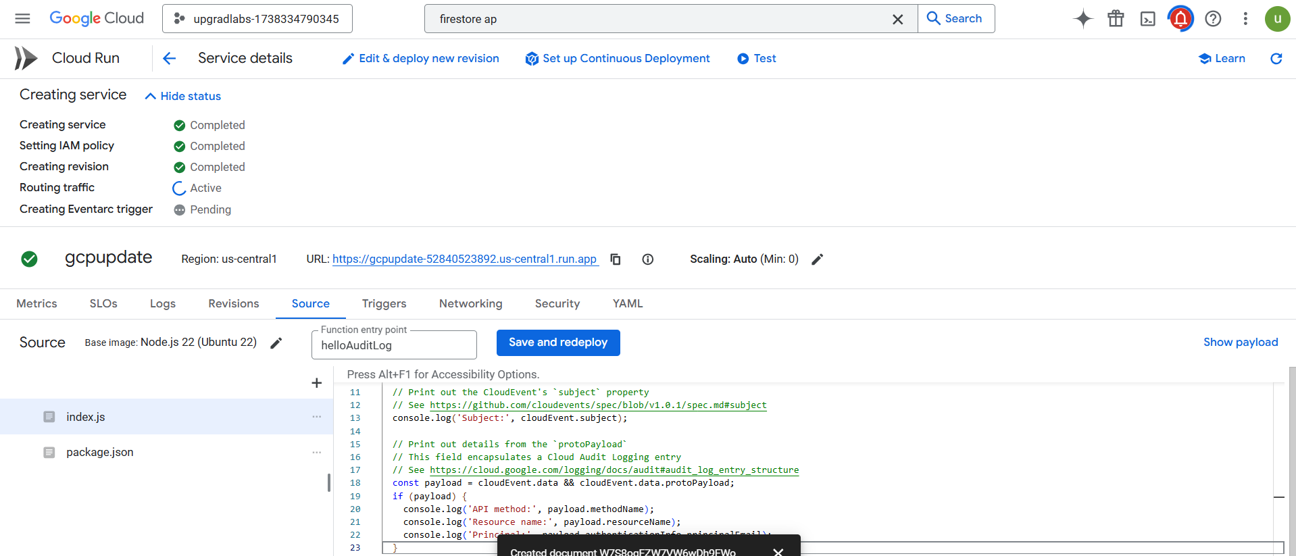

Error

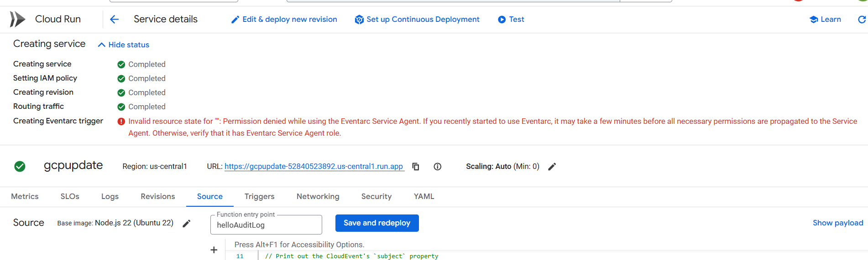

Sample code to update metadata index.js

const functions = require("firebase-functions");

const admin = require("firebase-admin");

const { Storage } = require("@google-cloud/storage");

admin.initializeApp();

const storage = new Storage();

exports.updateStorageMetadata = functions.firestore

.document("files_metadata/{fileId}")

.onUpdate(async (change, context) => {

const newData = change.after.data();

const { bucket, metadata } = newData;

if (!bucket || !metadata) {

console.error("Missing bucket or metadata");

return null;

}

const fileId = context.params.fileId;

const file = storage.bucket(bucket).file(fileId);

try {

await file.setMetadata({ metadata });

console.log(`Updated metadata for ${fileId}`);

} catch (error) {

console.error(`Failed to update metadata: ${error.message}`);

}

return null;

});